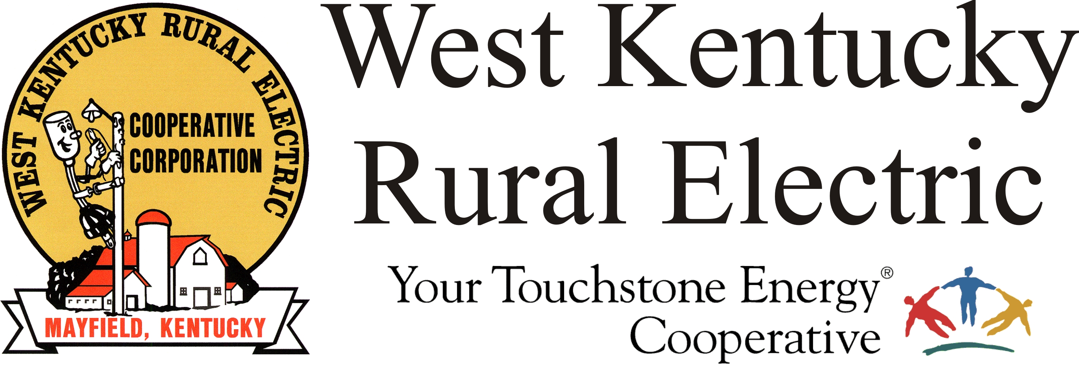

West Kentucky RECC Monday Morning
Storm Damage Update

(Mayfield, Ky.) Dec. 13, 2021 (9:30 a.m.) – Work continued last night on dual fronts to help restore service to the 6,500 West Kentucky RECC members who are still without service. TVA crews worked all night rebuilding sections of the transmission lines that deliver power to WKRECC’s John Ed Walker and Hickory Grove substations in Graves County. Meanwhile, lineworkers from WKRECC and several visiting co-ops worked through the night repairing damage to the electrical distribution system that delivers power to members’ homes and businesses.

We are also focusing on maximizing available power sources to serve as many members as possible. That’s why we have asked Graves County residents who do have service to conserve power whenever possible. The conservation efforts are paying off--we’ve seen usage drop, which allows us to return service to more members. Thank you for your support of this effort and please continue.

Because of the transmission outages, we don’t expect to see substantial reductions in the number of outages until TVA is able to resume service to our substations. We don’t have an estimate yet for when that might occur, but they are making good progress.

We have an important reminder for members: Do not attempt to move, reconnect, or in any way tamper with power lines. Doing so creates a serious risk for you, our lineworkers and members of the public. Violators will be prosecuted.

Reminders:

- Our business offices are closed today but customer service representatives are available to take your phone calls at 1-877-495-7322 for questions about your account.

- To report an outage or if you have a question about your service, email wkreccpower@gmail.com. Phone reporting should be restored later today.

- Disconnects for non-payment are temporarily suspended. We will notify members when disconnects resume.

Thanks to everyone for your patience, kindness and encouragement during this very challenging time.
###

Georgann Lookofsky
270-804-1701 or glookofsky@wkrecc.com

